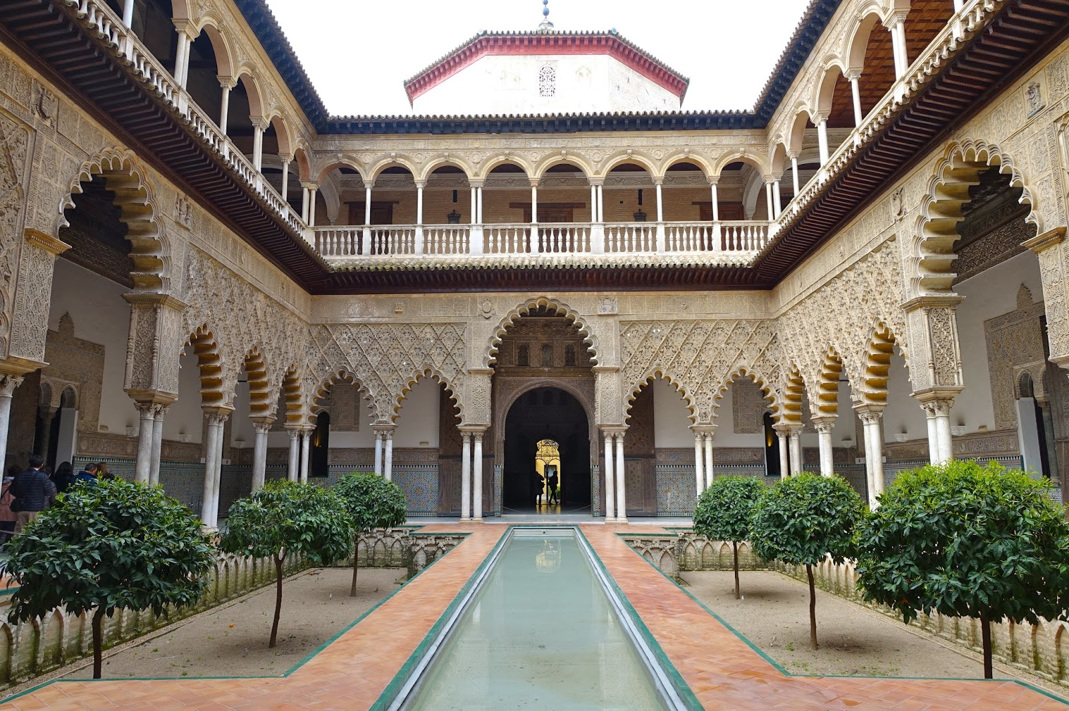

# Alcázar of Seville

The **Alcázar of Seville**, officially called **Royal Alcázar of Seville** ([Spanish](https://en.wikipedia.org/wiki/Spanish_language): *Real Alcázar de Sevilla or Reales Alcázares de Sevilla*),[[1]](https://en.wikipedia.org/wiki/Alc%C3%A1zar_of_Seville" \l "cite_note-1) is a historic royal palace in [Seville](https://en.wikipedia.org/wiki/Seville), [Spain](https://en.wikipedia.org/wiki/Spain). It was formerly the site of the [Islamic-era](https://en.wikipedia.org/wiki/Al-Andalus) citadel of the city, begun in the 10th century and then developed into a larger palace complex by the [Abbadid dynasty](https://en.wikipedia.org/wiki/Abbadid_dynasty" \o "Abbadid dynasty) (11th century) and the [Almohads](https://en.wikipedia.org/wiki/Almohad_Caliphate" \o "Almohad Caliphate) (12th to early 13th centuries). After the [Castilian](https://en.wikipedia.org/wiki/Crown_of_Castile) conquest of the city in 1248, the site was progressively rebuilt and replaced by new palaces and gardens. Among the most important of these is a richly-decorated [Mudéjar-style](https://en.wikipedia.org/wiki/Mud%C3%A9jar_art" \o "Mudéjar art) palace built by [Pedro I](https://en.wikipedia.org/wiki/Peter_of_Castile) during the 1360s.[[2]](https://en.wikipedia.org/wiki/Alc%C3%A1zar_of_Seville#cite_note-general2-2)[[3]](https://en.wikipedia.org/wiki/Alc%C3%A1zar_of_Seville#cite_note-:0-3)

The palace is a preeminent example of Mudéjar style in the [Iberian Peninsula](https://en.wikipedia.org/wiki/Iberian_Peninsula) and also includes sections with [Gothic](https://en.wikipedia.org/wiki/Gothic_architecture) and [Renaissance](https://en.wikipedia.org/wiki/Renaissance_architecture) elements. The upper stories of the Alcázar are still occupied by the [royal family](https://en.wikipedia.org/wiki/Spanish_royal_family) when they visit Seville and are administered by the [Patrimonio Nacional](https://en.wikipedia.org/wiki/Patrimonio_Nacional" \o "Patrimonio Nacional). It was registered in 1987 by [UNESCO](https://en.wikipedia.org/wiki/UNESCO) as a [World Heritage Site](https://en.wikipedia.org/wiki/World_Heritage_Site), along with the adjoining [Seville Cathedral](https://en.wikipedia.org/wiki/Seville_Cathedral) and the [General Archive of the Indies](https://en.wikipedia.org/wiki/General_Archive_of_the_Indies).[[4]](https://en.wikipedia.org/wiki/Alc%C3%A1zar_of_Seville#cite_note-unesco-4)

## **History**

In the year 712, Seville was conquered by the [Umayyad Caliphate](https://en.wikipedia.org/wiki/Umayyad_Caliphate). In the year 913–914, after a revolt against Cordoba's government, the first [caliph](https://en.wikipedia.org/wiki/Caliphate) of Al-Andalus [Abd al-Rahman III](https://en.wikipedia.org/wiki/Abd_al-Rahman_III" \o "Abd al-Rahman III) built a fortified construction in place of a [Visigothic](https://en.wikipedia.org/wiki/Visigoth" \o "Visigoth) Christian basilica.[[9]](https://en.wikipedia.org/wiki/Alc%C3%A1zar_of_Seville#cite_note-esp-9) It was a quadrangular, roughly square enclosure about 100 meters long on each side, fortified with walls and rectangular towers, and annexed to the city walls.[[10]](https://en.wikipedia.org/wiki/Alc%C3%A1zar_of_Seville#cite_note-reales-10)[[11]](https://en.wikipedia.org/wiki/Alc%C3%A1zar_of_Seville#cite_note-:32-11) In the 11th century, during the *[Taifa](https://en.wikipedia.org/wiki/Taifa" \o "Taifa)* period, the [Abbadid](https://en.wikipedia.org/wiki/Abbadid_dynasty" \o "Abbadid dynasty) king [Al-Mu'tamid](https://en.wikipedia.org/wiki/Al-Mu%27tamid_ibn_Abbad) expanded the complex southwards and eastwards,[[10]](https://en.wikipedia.org/wiki/Alc%C3%A1zar_of_Seville#cite_note-reales-10) with a new southern enclosure measuring approximately 70 by 80 meters.[[11]](https://en.wikipedia.org/wiki/Alc%C3%A1zar_of_Seville#cite_note-:32-11) This new palace was called *Al Mubarak* ([Arabic](https://en.wikipedia.org/wiki/Arabic_language): المبارك).[[2]](https://en.wikipedia.org/wiki/Alc%C3%A1zar_of_Seville#cite_note-general2-2) Various additions to the construction such as stables and warehouses were also carried out.[[9]](https://en.wikipedia.org/wiki/Alc%C3%A1zar_of_Seville#cite_note-esp-9)

Towards 1150, the [Almohad Caliphs](https://en.wikipedia.org/wiki/Almohad_Caliphate" \o "Almohad Caliphate) began to develop Seville as their capital in Al-Andalus. The Almohad governor extended the fortified complex to the west, nearly doubling its size. At least six new courtyard palaces were constructed in the old enclosures and nine palaces were added in the western extensions.[[11]](https://en.wikipedia.org/wiki/Alc%C3%A1zar_of_Seville#cite_note-:32-11) In 1163 the caliph [Abu Ya'qub Yusuf](https://en.wikipedia.org/wiki/Abu_Yaqub_Yusuf) made the Alcazar his main residence in the region.[[9]](https://en.wikipedia.org/wiki/Alc%C3%A1zar_of_Seville#cite_note-esp-9)[[11]](https://en.wikipedia.org/wiki/Alc%C3%A1zar_of_Seville#cite_note-:32-11) He further expanded and embellished the palace complex in 1169, adding six new enclosures to the north, south, and west sides of the existing palaces. The works were carried out by architects Ahmad ibn Baso and 'Ali al-Ghumari.[[11]](https://en.wikipedia.org/wiki/Alc%C3%A1zar_of_Seville#cite_note-:32-11) With the exception of the walls, nearly all previous buildings were demolished, and a total of approximately twelve palaces were built.[[10]](https://en.wikipedia.org/wiki/Alc%C3%A1zar_of_Seville#cite_note-reales-10) Among the new structures was a very large garden courtyard, now known as the *Patio del Crucero*, which stood in the old Abbadid enclosure. Between 1171 and 1198 an enormous new [congregational mosque](https://en.wikipedia.org/wiki/Congregational_mosque) was built on the north side of the Alcazar (later transformed into the current [Cathedral of Seville](https://en.wikipedia.org/wiki/Seville_Cathedral)). A shipyard was also built nearby in 1184 and a textiles market in 1196.